Lab 6.1 Run MySQL database in Docker Container

This section will show you how to run MySQL database in Docker Container.

This lab has 3 sub-sections:

* + 1. Clone the repository from Git
    2. Inspect the IP address
    3. Run MySQL database instance in Docker

**Step 6.1.1:** Clone the repository from Git

Clone the git repository:

git clone <https://github.com/SimplilearnDevOpsOfficial/DockerWithMySQL.git>

Change to the lab directory.  
cd DockerWithMySQL

Create a Docker data volume to hold the database.

docker volume create --name monitoring_data

Confirm that the data volume has been created.

docker volume ls

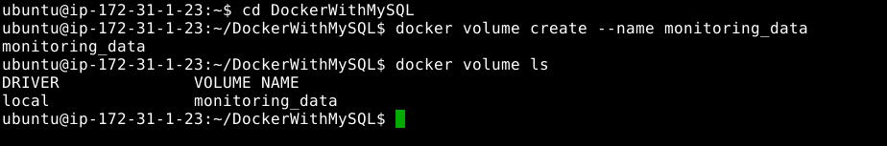

Provide access to perform action on the file.

chmod u+x runserver_first

Examine the script that will run and create the case study database structure.

cat runserver_first

Run

./runserver_first

You should be able to see that the connection is up and running at the specific port number.

Run the script to create a container with MySQL running and create the database.

docker images

You will need to monitor the logs to see when MySQL has completed creating the student database and is waiting for connections. This may take several minutes to complete.

docker logs mysql

When you see the following in the logs, you may continue. Run the command until you see this.

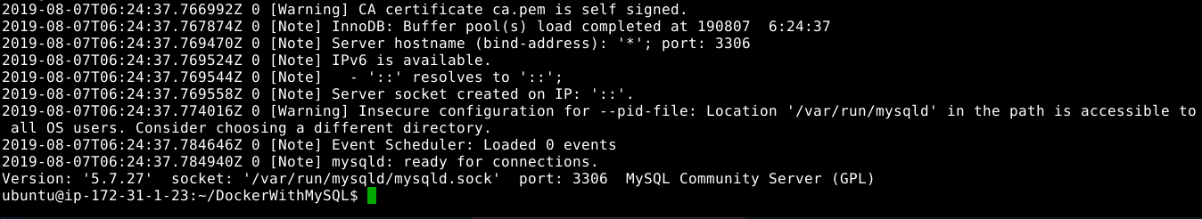

**Step 6.1.2:** Inspect the IP address

Find the IP address of the server.

docker inspect mysql

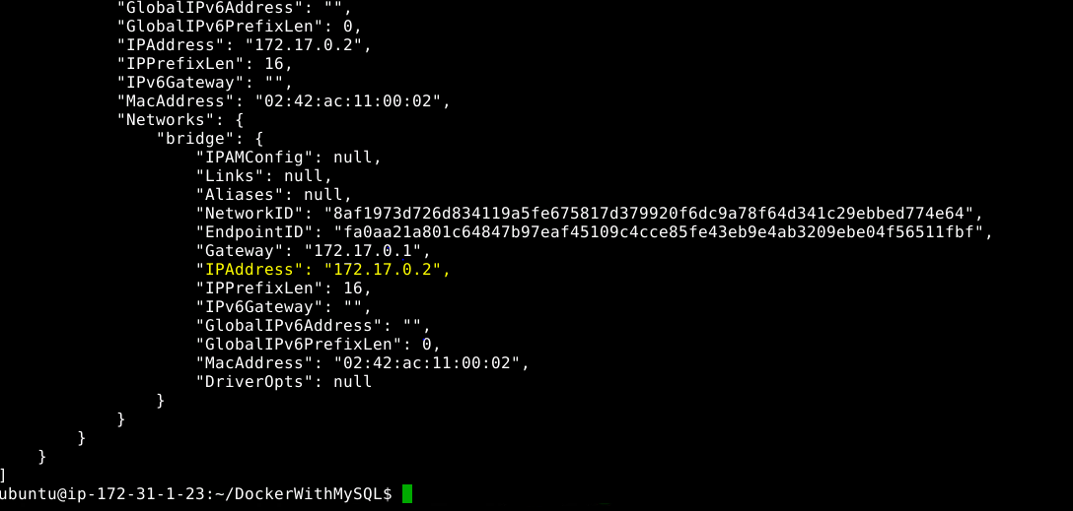

To run the client and log the data in the database. Use the command given below:

run

chmod 777 runclient

./runclient



**Step 6.1.3:** Run MySQL database in Docker container

You will be working at **root** level. You will be placed inside the client container running the Bash command shell. You can now type commands to use the database. You may need to change the IP address to that of the server.

Type the following:

**mysql -h 172.17.0.2 -u student -p**

Password is student

When you connect, you will see the MySQL client prompt **mysql>** as shown below:

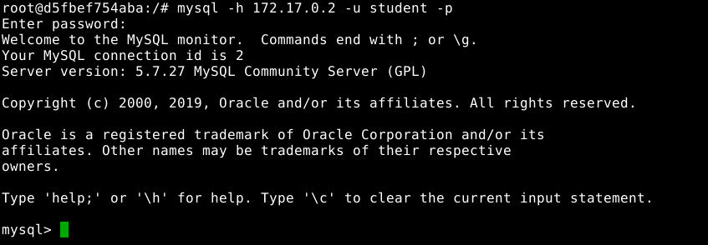

Examine the database tables (Feel free to explore more).

mysql> show databases;

mysql>use monitoring;

mysql> show tables;

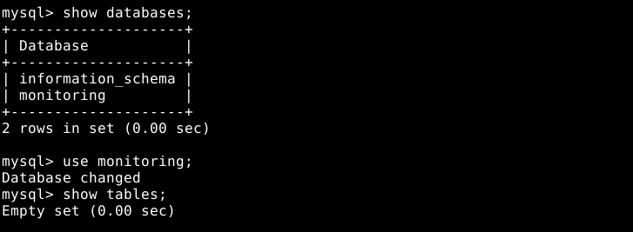

mysql>create table docker(name VARCHAR(20));

mysql> show tables;

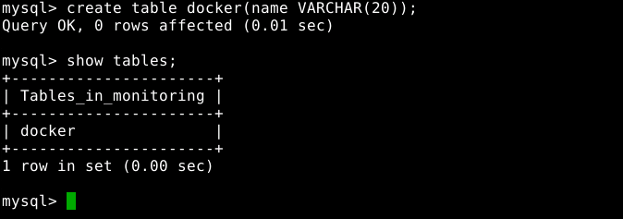

Exit from the MySQL client.

mysql> quit;

Exit from the client container (Please refer to the screenshot below).

exit

